Jadavpur University

Department of Electronics and Telecommunication Engineering,

Faculty of Engineering & Technology

DSA LAB REPORT

2nd Year First Semester 2020



Name : RAHUL SAHA

Roll: 001910701009

Group 1

POSTFIX IMPLEMENTATION USING STACKS AND TOWER OF HANOI

Assignments - 03

1. ***Evaluate postfix expressions using a Stack. You can use ',' as a delimiter between two tokens in an expression. You can use '$' as the end of input. Always show the intermediate steps including the content of the stack. Take some example postfix expressions. Here is one example:***

***6, 2, 3, +, -, 3, 8, 2, /, +, *, 2, ^, 3, +, $***

***(Use '^' for exponentiation)***

**Code of Postfix Implementation Using Stack:**

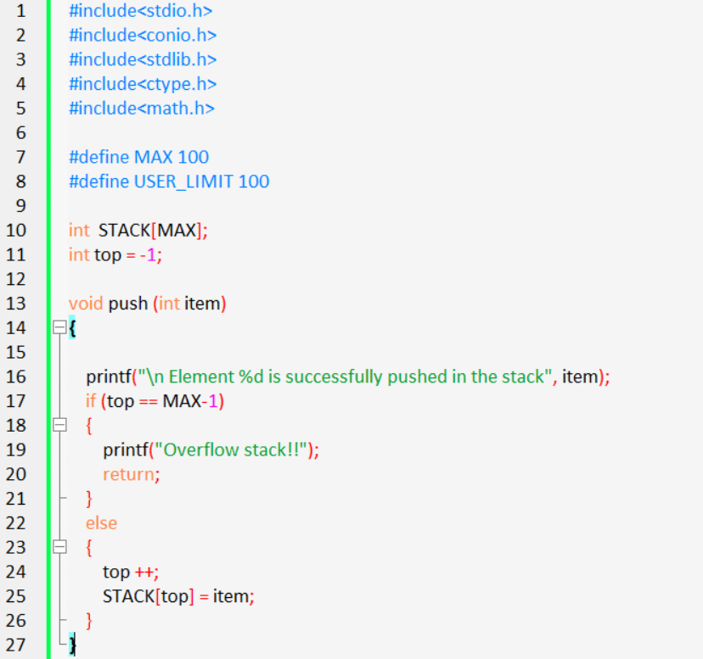

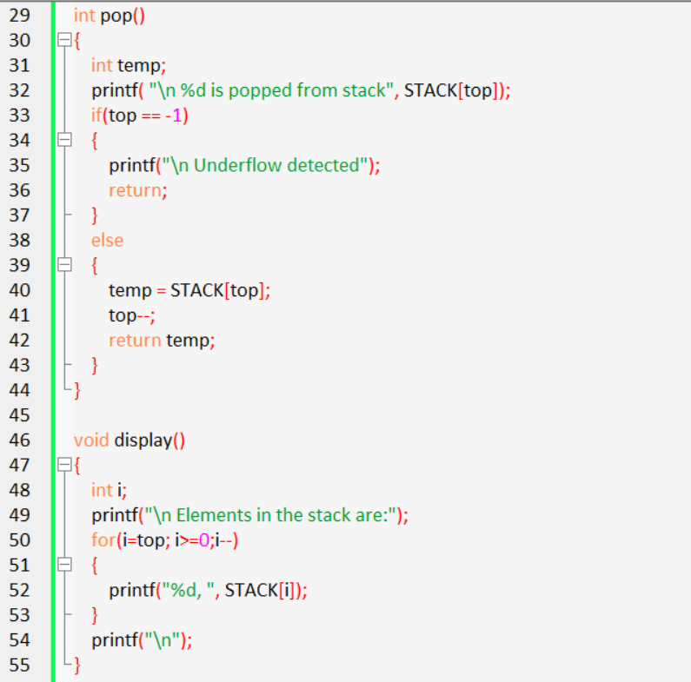

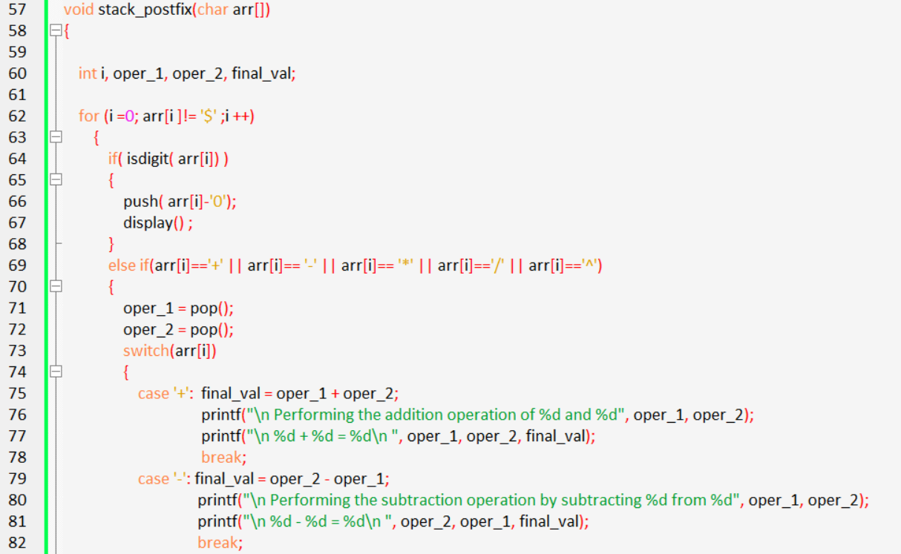

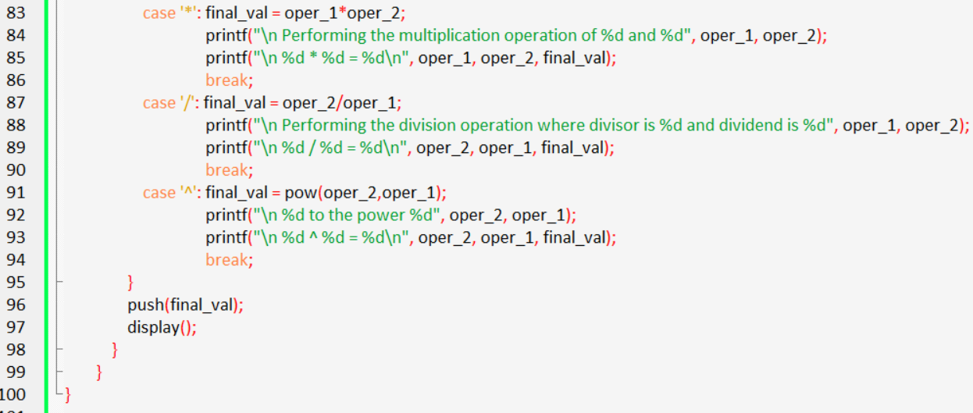

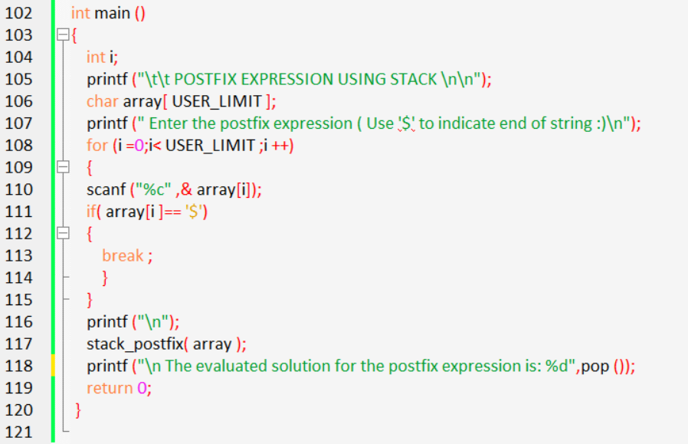

**Output(s):**

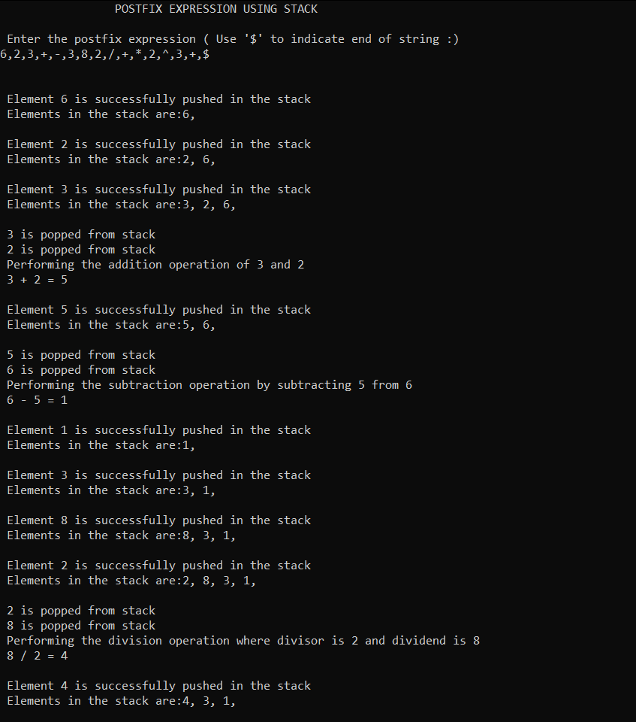

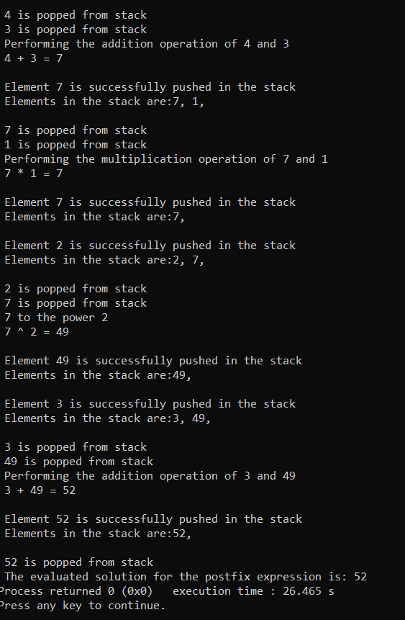

***Q2. Write a program for the Tower of Hanoi problem. Experiment with a varying number of discs. Show the intermediate moves in form of messages like the following:***

***Move disk ... from rod ... to rod ...***

**Code Of TOWER OF HANOI**

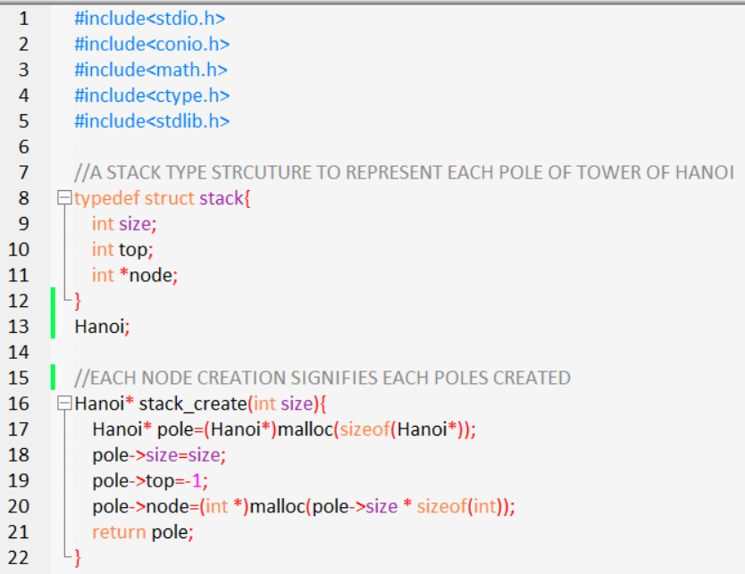

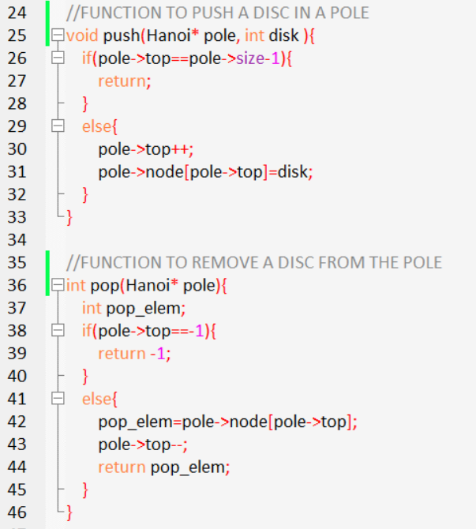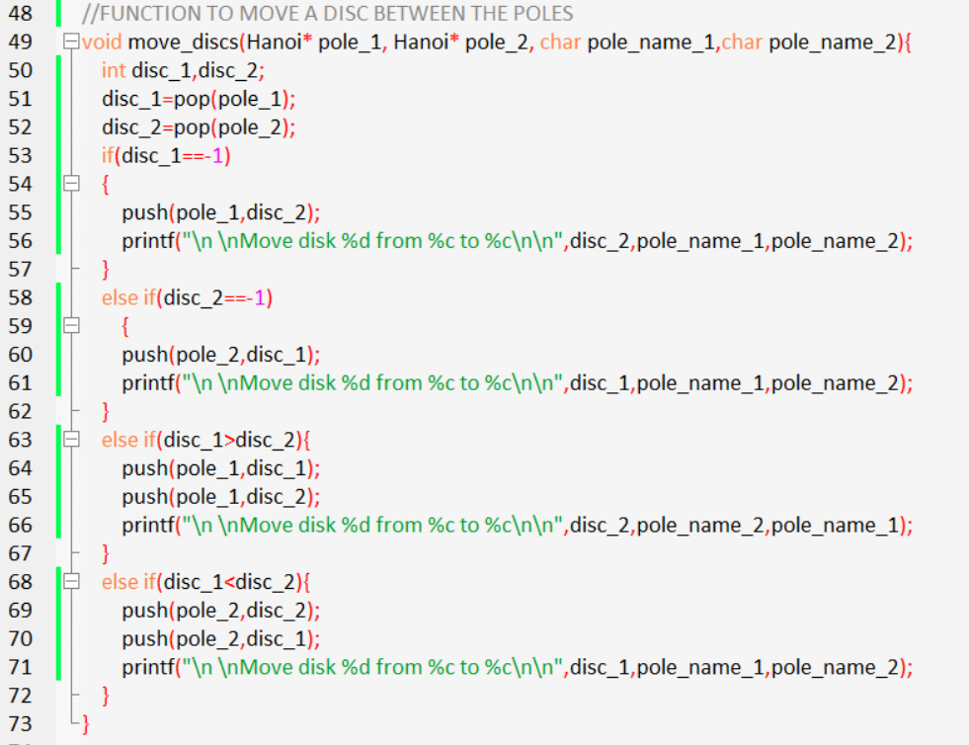

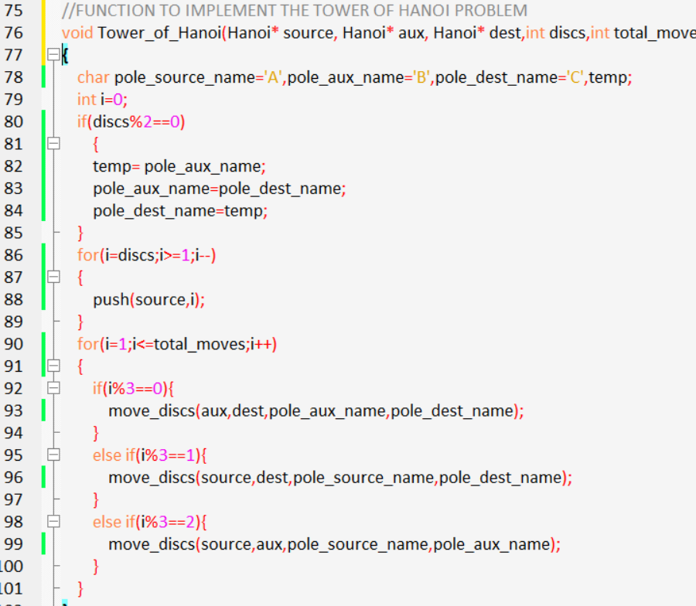

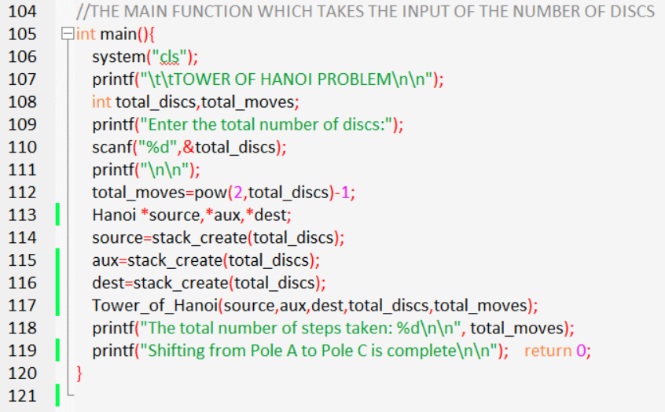

**Output(s):**

1. **With 3 Discs**

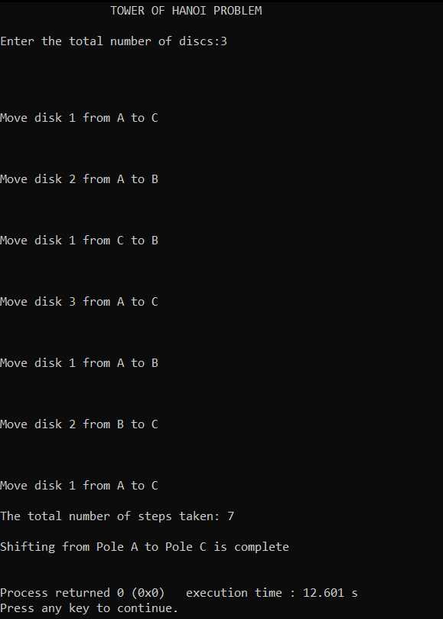

1. **With 4 discs**

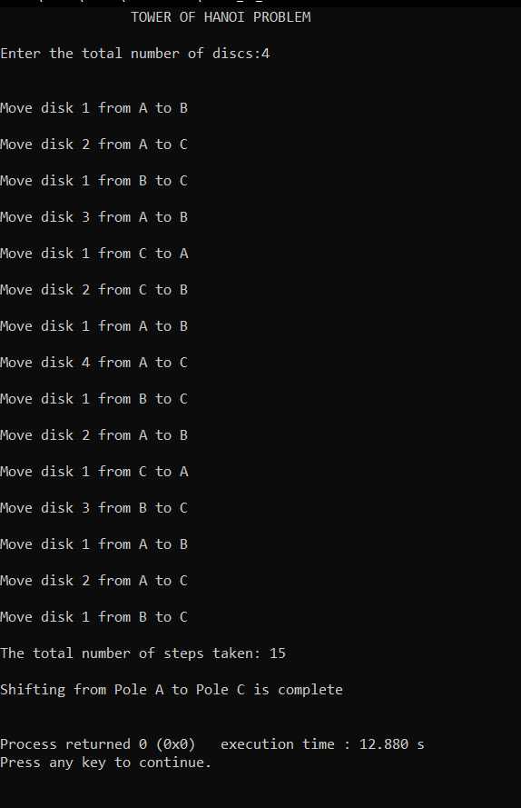

1. **With 5 discs**

